Wilson Basketball
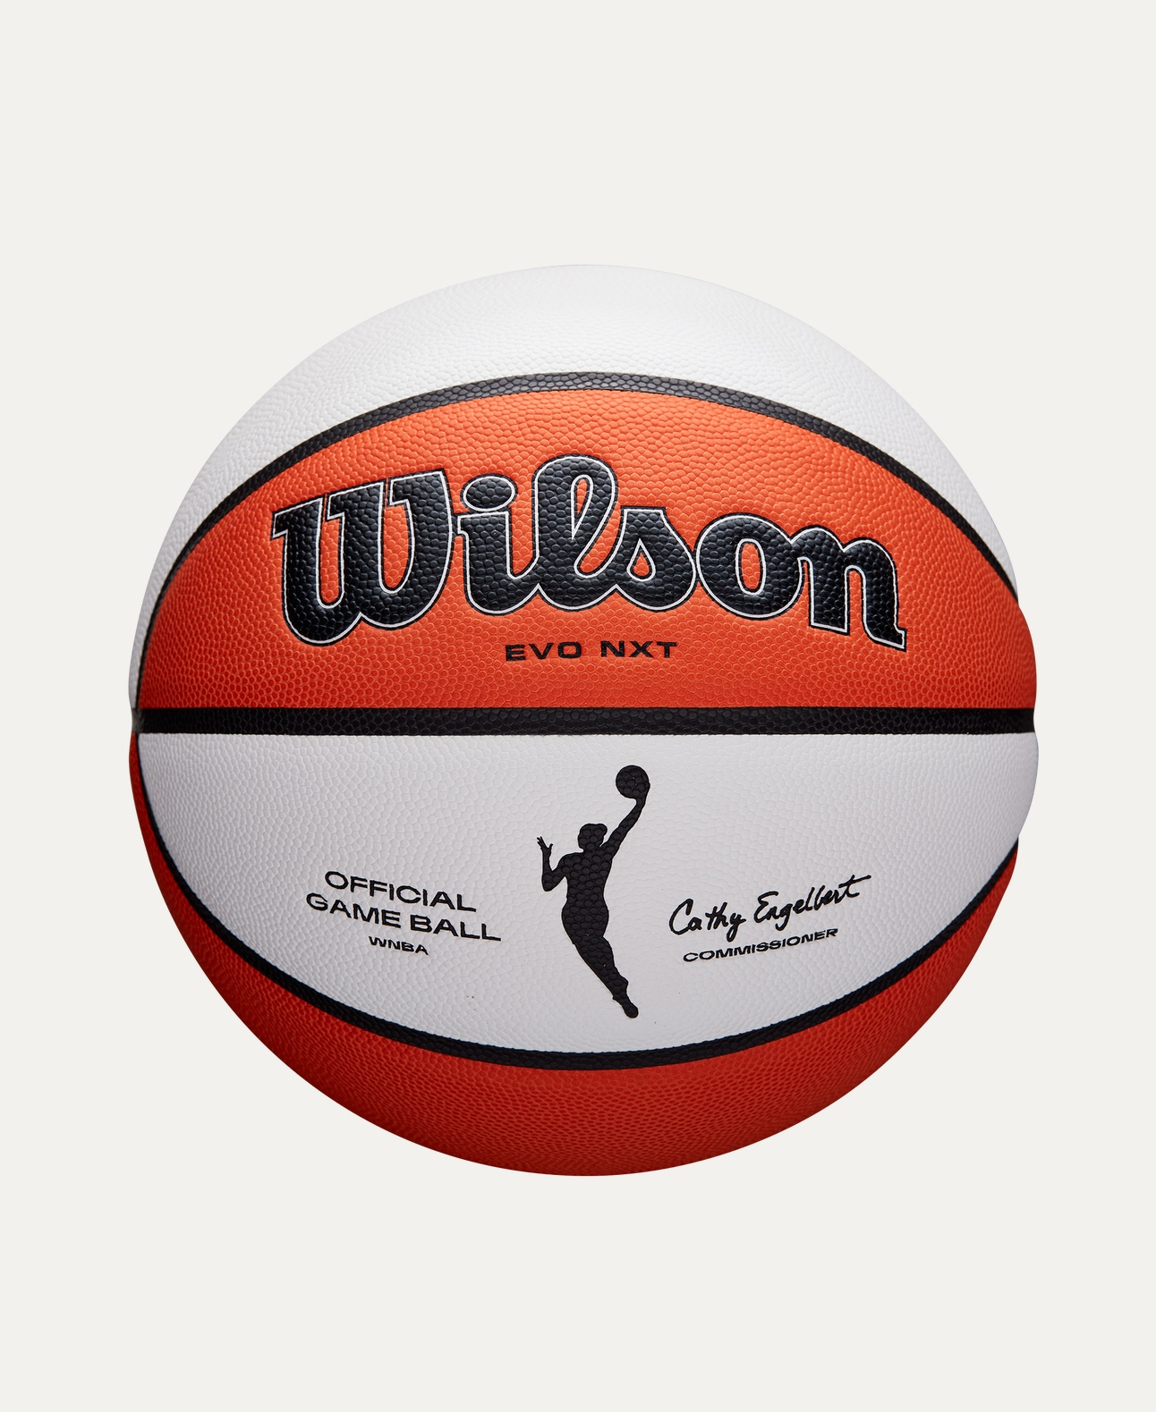
Price: Approximately Rs 25,000
Introduction
The Wilson Basketball is designed for players who demand excellent grip, control, and durability. Suitable for both indoor and outdoor play, it delivers consistent performance for practice and competitive games.

Product Overview
This Wilson Basketball is crafted to provide superior handling and accurate bounce. Its well-balanced construction ensures smooth dribbling, controlled passing, and reliable shooting performance.

About the Brand
Wilson is a globally trusted sports brand and an official partner of professional basketball leagues. Known for innovation and premium quality, Wilson basketballs are widely used by athletes at all levels.

Key Features
- Excellent grip for better ball control
- Consistent bounce and balance
- Durable surface for long-lasting use
- Suitable for indoor and outdoor courts
- Professional-grade construction

Design & Build Quality
The basketball features a classic panel design with deep channels that improve grip and control. Its solid construction ensures stable performance even during intense gameplay.

Storage & Capacity
Compact and easy to store, the ball fits conveniently in sports bags or storage racks without losing its shape.

Material & Durability
Made from high-quality rubber or composite leather (depending on model), the Wilson Basketball is built to withstand rough surfaces and regular use.

Ideal For
- Beginner to professional players
- Training sessions and matches
- Schools, academies, and clubs
- Indoor and outdoor basketball courts

Care Instructions
- Clean with a damp cloth after use
- Avoid over-inflation
- Store in a cool, dry place
- Keep away from sharp objects

Product Specifications
- Brand: Wilson
- Product Type: Basketball
- Material: Rubber / Composite Leather
- Size: Standard sizes available (Size 5, 6, 7)
- Court Type: Indoor / Outdoor
- Usage: Training & Match Play

Product Summary
The Wilson Basketball offers durability, control, and consistent performance for players of all levels. Whether for practice or competitive play, it is a reliable choice backed by a world-class sports brand.

Thank you

